STAGE S0
Problem Definition & Need Identification

Team No. | 2
Theme No. | 1
Artefact Name: | Enterprise Procurement & Inventory Workflow Management System
Team Members | 1. Satish Batakurki  2. Rakshita Kadam  3. Swyambu V B  4. Aditya Hegde
Guide Name | Mrs Indira Bidari

THE PROBLEM
Problem Definition & Need Identification
Stage S0 — Problem Definition & Need Identification

Foundational Courses
SI.No. | Course | Core Concepts
1. | DBMS | Relational Database, Normalization, Primary/Foreign Keys, SQL, Joins, Transactions, ACID Properties, Constraints, Concurrency Control
2. | Data Structures & Algorithms | Arrays/Lists, Queues, Searching, Sorting, Hashing, Graphs
3. | Operating Systems | Process/Thread, Concurrency, Synchronization, Critical Section, Race Condition, Mutual Exclusion, Deadlock, Scheduling, Resource Management
4. | Software Engineering & SDLC | Requirement Analysis, Use Cases, UML Diagrams, Workflow Modelling, Modular Design, Testing, Validation & Verification
5. | Web Technologies & Networks | Client-Server Architecture, HTTP/HTTPS, REST API, Request Response Model, Authentication & Authorization TCP/IP, Session/Token Management
6. | Discrete Mathematics | Sets, Relations, Functions/Mappings,Predicates, Graphs, Constraints, Set Operations

2. Existing Problem / Current Situation
In most small and mid-sized organizations, the purchase procurement workflow, from an customer raising a requirement to the final payment to a vendor is handled manually through phone calls, emails and spreadsheets. A purchase requirement typically moves through several people and departments:
Customer -> Shopkeeper ->Procurement -> Vendor -> Warehouse -> Finance. Because no single system tracks a request across these stages, information about a request's current status is scattered across people and channels instead of being available in one place.

3. Who Is Affected
Customers who raise purchase requirements (often on behalf of a customer visiting in person) Shopkeeper who approve or reject them
Shopkeepers who coordinate with vendors
Vendors/Dealers who supply stock
Shop Staff who receive goods and update inventory
Finance Officers who process invoices and payments.

4. Why the Existing Approach Is Inadequate
There is no centralized record of a request's status, so customer and shopkeeper cannot tell whether a request is pending, approved or ordered without asking someone directly. Vendor stock information is not centralized, so shopkeeper must call multiple dealers individually, and the stock figures they are quoted can change before an order is actually confirmed (stock volatility). There is no enforced sequence for how a request should move through approval, ordering, receipt and payment, so records become inconsistent, requests can be duplicated or lost, and there is no audit trail showing who did what and when.

5. Evidence That This Problem Is Real
Evidence gathered through informal discussion and observation of the current process includes:

1] instances where a vendor's quoted stock did not match the quantity actually available at order time
2] delays traced to procurement having to call several vendors one at a time instead of checking a single record
3] inconsistent or missing records when trying to trace a completed order back through approval, delivery and payment.

6. Sources / References
Informal discussions with customers, shopkeepers and warehouse personnel involved in the current purchase process
direct observation of the existing phone/email/spreadsheet-based workflow
review of similar enterprise procurement and inventory management systems for comparison.

1. Stakeholder Table

Stakeholder | Role / Description | Needs & Expectations | Current Pain Points | Influence (H/M/L)
Customer | Raises purchase requirements, often on behalf of a customer visiting in person | A simple way to log a request and track its status | No visibility into approval/order status once submitted | M
Shopkeeper | Approves or rejects purchase requests | Quick, reliable information to approve or reject a request | Must follow up manually to get request details before approving | H
Shopkeeper | Selects a vendor and places the purchase order | Centralized, up-to-date vendor and stock information | Must call multiple vendors individually; stock info can be outdated | H
Vendor / Dealer | Supplies requested items and reports stock availability | Clear, unambiguous orders and timely communication | Miscommunication over phone regarding required quantity/availability | M
Shop Staff | Receives goods and updates inventory | Orders clearly linked to what is actually delivered | Inventory updates are manual and disconnected from the purchase order | M
Finance Officer | Processes invoices and payments | Accurate, linked records of order, receipt and invoice | Manual reconciliation of purchase, receipt and invoice data | H
Dealers  Organization | Oversees overall procurement efficiency and cost | Visibility into delays, costs and process bottlenecks | No consolidated reporting on procurement performance | L

Primary vs. Secondary Stakeholders
Primary Stakeholders
Secondary Stakeholders

Customer | Warehouse Staff
Shopkeeper | Top Management / Organization
Finance Officer | IT / System Administrator
Vendor | Auditors
 | Vendor

Key Insight Summary

The stakeholder analysis shows the system must primarily serve the internal staff who operate the procurement workflow day to day: customers, shopkeepers, warehouse staff and finance officers since they are directly blocked by the lack of a shared, trackable system. Approval visibility and centralized vendor/stock information are the two needs that affect the largest number of stakeholders, because delays for managers and procurement staff cascade downstream to warehouse and finance. Vendors, although a secondary stakeholder, have high influence on data accuracy because stock volatility originates with them. Overall, the system should prioritize real-time, role-based visibility for internal roles over any customer-facing feature.

HOW IT WORKS TODAY
Step 3 of 7 — S0 Problem Definition & Need Identification
Problem Definition & Need Identification

1. Current Process — Narrative Summary
Today, a purchase requirement typically starts when an customer identifies a need and informs their shopkeeper verbally or by email. The shopkeeper reviews and approves or rejects the request informally. Once approved shopkeeper manually contacts one or more vendors by phone to check availability and price, without access to a centralized, up-to-date vendor-stock record. After a vendor is selected, the order is placed over phone or email with no standard document trail. When goods arrive, shop staff receive them and update stock in a separate spreadsheet or register, not linked to the original order. Finally, the finance team manually cross-checks the vendor invoice against the order and delivery before releasing payment. At no point in this process is there a single, shared view of a request's status.

2. Step-by-Step Workflow Table
Step No. | Actor / Role | Action Performed | Tool / System Used | Pain Point Observed
1 | Customer | Identifies the purchase requirement and informs the manager | Verbal / Email | No formal record of the request is created
2 | Shopkeeper | Reviews and approves or rejects the request | Verbal / Email | Approval decision is not logged or visible to others
3 | Shopkeeper | Calls vendors to check stock and price | Phone calls | Vendor stock data is outdated/unreliable; no central vendor record
4 | Shopkeeper | Selects a vendor and places the order | Phone / Email | No standardized purchase order document or tracking ID
5 | Vendor | Confirms and delivers the ordered goods | Phone / Physical delivery | Delivered quantity may not match what was originally confirmed
6 | Shop Staff | Receives goods and updates inventory | Spreadsheet / Register | Inventory update is disconnected from the original purchase order
7 | Finance Officer | Verifies the invoice and processes payment | Spreadsheet / Manual cross-check | Time-consuming manual reconciliation across order, receipt and invoice

3. Workflow Diagram
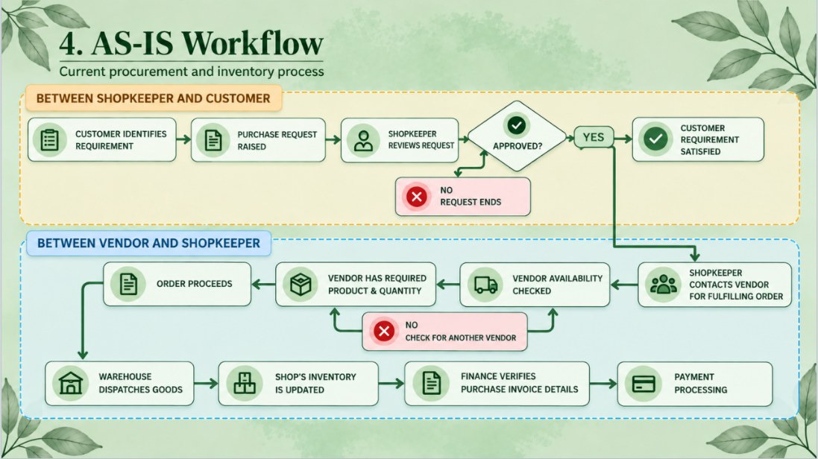

Bottlenecks & Inefficiencies Identified
Fragmented information: request, approval, vendor, stock and payment details live in different places (calls, emails, spreadsheets) with nothing linking them together.
No real-time approval visibility: customers and shopkeepers cannot check a request's current status without asking directly.
Manual, unreliable vendor coordination: shopkeepers must call multiple vendors individually, and quoted stock can change before the order is confirmed (stock volatility).
No enforced order-to-vendor rule: there is no systematic way to ensure the full required quantity is sourced from a single, capable vendor.
Disconnected inventory updates: warehouse stock is updated separately from the purchase order that generated the delivery.
No traceability: there is no audit trail showing who created, approved, ordered, received or paid for a request, making delays and errors hard to investigate.

PROBLEM & GOALS
Step 4 of 7 — S0 Problem Definition & Need Identification
Stage S0 — Problem Definition & Need Identification │ General, Theme-Independent

1. Observed Problems → Underlying Needs
Observed Problem | Evidence / Source | Underlying Need | Linked Stakeholder(s)
No central tracking of purchase requests | Observed in the AS-IS process requests have no ID or stored status | A system that records every request with a unique ID and status | Customer,shopkeeper
No visibility of approval status | Customer must ask shopkeepers directly to know if a request is approved | Real-time, role-based visibility of request/approval status | Customer,shopkeeper
Manual, one-by-one vendor coordination | Shopkeeper calls each vendor individually to check stock | A centralized, queryable vendor/stock record | Shopkeeper, Vendor
Vendor stock changes between quote and order confirmation (stock volatility) | Quoted stock did not match delivered quantity in observed cases | Stock data updated/checked close to order time, with safe concurrent updates | Shopkeeper, Vendor, Warehouse Staff
Selected vendor may not have the full required quantity | No system exists to identify a single vendor able to fulfil an order without splitting it | An automated way to find/select a vendor with sufficient stock, or trigger a restock | Shopkeeper
No traceability of who did what and when | No audit record across request creation, approval, ordering, receipt and payment | An audit log linking every workflow action to a user and timestamp | Shopkeeper Warehouse Staff, Finance Officer

2. Prioritization
1) Approval visibility and request tracking are prioritized highest, since every later step in the workflow depends on knowing a request's current state.
2) Centralized vendor/stock coordination and handling stock volatility come next, as they directly cause order delays and mismatched deliveries.
3) The single-vendor, sufficient-quantity rule is prioritized above general vendor coordination since it is a specific business rule the system must enforce.
4) Traceability/audit logging is ranked last for the current semester scope: it is valuable but does not block day-to-day operation of the core workflow, so it can be layered on once tracking and approval are in place.
Priority order: 1) Approval visibility & request tracking 2) Centralized vendor/stock coordination & stock volatility handling 3) Single-vendor sufficient-quantity rule 4) Traceability / audit logging.

3. Problem Statement
For customers,shopkeepers, warehouse staff and finance teams, the current manual, phone-and-spreadsheet-based procurement process causes fragmented information and poor coordination between departments resulting in delays, inconsistent records, and limited visibility of purchase request, vendor and order status across the Customer -> Shopkeeper -> Procurement -> Vendor -> Warehouse -> Finance workflow.

4. Project Objectives
1. To design a centralized database that records every purchase request with a unique ID and a status that moves through defined stages (Pending -> Approved -> Vendor Selected -> Ordered -> Received -> Completed).
2. To provide role-based, real-time visibility of request and approval status to customers, shopkeepers, warehouse staff and finance officers.
3. To maintain a centralized vendor/stock record so shopkeepers can identify, within the system, a single vendor capable of fulfilling the full required quantity of an order.
4. To ensure inventory/stock updates happen safely and consistently under concurrent access, preventing race conditions during stock updates.
5. To maintain a complete audit trail (who created, approved, ordered, received and paid for each request) so every transaction is traceable end-to-end.

WHAT'S INCLUDED
Step 5 of 7 — S0 Problem Definition & Need Identification
Stage S0 — Problem Definition & Need Identification │ General, Theme-Independent

1. In-Scope
# | In-Scope Item
1 | Recording and tracking purchase requests with unique IDs and defined status stages
2 | Role-based approval workflow for Customers, Shopkeepers, Vendor
3 | Centralized vendor and stock database with logic to select a single sufficient vendor
4 | Warehouse inventory update linked to the originating purchase order
5 | Finance module linking purchase orders, goods received, invoices and payment status
6 | Audit log capturing user, action and timestamp for every workflow transition

2. Out-of-Scope
# | Out-of-Scope Item | Reason for Exclusion
1 | Direct customer-facing ordering interface | Customers place orders through shopkeeper,and direct customer ordering portal is not included in current project scope
2 | Automated payment gateway integration | Only recording payment status is in scope; actual payment processing is excluded
3 | Splitting a single order across multiple vendors | The project enforces a one-purchase-order-one-vendor rule; partial/split fulfilment is excluded
5 | Mobile application version | Only a web-based system is planned for this semester; mobile is a possible future extension
6 | Integration with external ERP/accounting systems | Would require access to third-party systems not available within the project timeline

3. Assumptions
The organization has at least one device with internet access to use the system. Vendors are willing to have their stock and contact information recorded and periodically updated in the system (even if entry is still done manually by procurement staff). Sample/simulated data (requests, vendors, stock, invoices) can be used for development and testing where live production data is unavailable.

4. Constraints
Access to a real organization's live procurement data is limited, so the system will largely be developed and demonstrated using representative/sample data.

CAN WE DO THIS
Step 6 of 7 — S0 Problem Definition & Need Identification
Stage S0 — Problem Definition & Need Identification │ General, Theme-Independent

1. Technical Feasibility
Aspect | Assessment | Justification
Technical | Feasible | Requires a relational database, a backend web application and basic concurrency handling -- all covered by the team's DBMS, DSA, OS and Web Technologies coursework; no unfamiliar technology is required.
Operational | Feasible with training | Staff will need a short walkthrough, but the workflow mirrors their existing process, so adoption friction should be low.
Time | Feasible with a tight schedule | Core request-tracking, approval and vendor-selection features can be built within scheduled weeks if scope is kept to the In-Scope list; stretch features should be deferred.
Resource | Feasible | The team has access to standard development tools (IDE, database, demo hosting); no specialized hardware is required.

2. Operational Feasibility
The proposed system automates a process staff already perform manually, so it does not require an entirely new way of working -- only a new tool for an existing workflow. Role-based access (Customers, Shopkeepers, Warehouse Staff, Finance Officer) mirrors the real organizational roles already in place, which should ease adoption. The main operational risk is staff falling back on phone/email during the transition.

3. Time Feasibility
Within the 12-week semester, early weeks are allocated to requirements and design , a middle phase to core implementation (request tracking, approval workflow, vendor/stock database, and concurrency handling for stock updates), and later weeks to the warehouse/finance modules, testing and refinement. Out-of-Scope items (customer portal, payment gateway, split orders, forecasting, mobile app, ERP integration) are excluded specifically to keep this timeline realistic.

4. Resource Feasibility
The team's size and skills among team members are expected to be sufficient for a standard three-tier web application (database, backend, frontend), consistent with concepts already covered in DBMS, DSA, OOPS and Web Technologies coursework. No specialized hardware, paid APIs, or licensed software are required; open-source/free tools are sufficient. Sample/simulated data will be used in place of live organizational data, removing dependency on external data-sharing agreements.

5. Overall Feasibility Conclusion
Going with a scope disciplined to the items listed under In-Scope. The project is technically achievable using concepts (DBMS, DSA, OS, OOPS, Web Technologies, Discrete Mathematics), operationally realistic since it automates an existing manual process, and time-feasible within 15 weeks provided the team defers all Out-of-Scope items to a later phase or future work.

WHAT COULD GO WRONG
Step 7 of 7 — S0 Problem Definition & Need Identification
Stage S0 — Problem Definition & Need Identification │ General, Theme-Independent

1. Project-Level Risks
Risk ID | Risk Description | Category | Likelihood (H/M/L) | Impact (H/M/L) | Mitigation Strategy
R1 | Underestimating time needed for concurrency/synchronization logic for stock updates | Technical | M | H | Start with a simple locking/transaction-based approach first; treat advanced concurrency handling as a stretch goal
R2 | Scope changes | Scope | M | H | Strictly follow the agreed In-Scope/Out-of-Scope list; any addition requires a documented scope-change review
R3 | Limited access to real organizational/vendor data for testing | Resource | H | M | Use representative sample/synthetic data for development and demo
R5 | Delay in finalizing requirements | Timeline | L | H | Lock this Problem Definition document and move promptly into S1 Requirements Engineering
R6 | Vendor stock data becoming stale since vendors do not enter data themselves | Data Quality | H | M | Require procurement staff to refresh vendor stock data at defined intervals
R7 | Difficulty enforcing the single-vendor-per-order business rule in all edge cases | Technical | M | M | Write explicit test cases for the vendor-selection before building the UI around it

2. Risk Owner Summary

Risk ownership will be assigned once team member roles are finalized (e.g., a Database/Backend owner, a Frontend owner, a Testing/QA owner, and a Documentation/Coordination owner). Each risk above should be assigned to the team member whose module it most affects -- for example, concurrency/stock-update risks to whoever owns the database/backend.

